Sitemap

A sitemap is a list or diagram which represents the hierarchical structure of the html pages in a website.it file where you provide information about the pages ,videos, and other files on your site and the relationship between them. Search engine like google read this file to crawl your site more efficiently. A sitemap tells google which pages and files you think are important in your site, and also provides valuable information about these files. For example when the page was last updated and alternate language versions of the page. I like to think of Sitemaps like a roadmap for your website or app. But, instead of cities and towns, a Sitemap shows the different categories and subcategories. And just like roads on a map, a Sitemap shows how these categories and subcategories are connected.

You can use a sitemap to provide information, about specific types of content on your pages , including video, image, and news content , for example:

* A sitemap video entry can specify the video running time, category, and age-appropriateness rating,
* A sitemap image entry can include the image subject matter, type, and license.
* A sitemap news entry can include the article title and publication date.

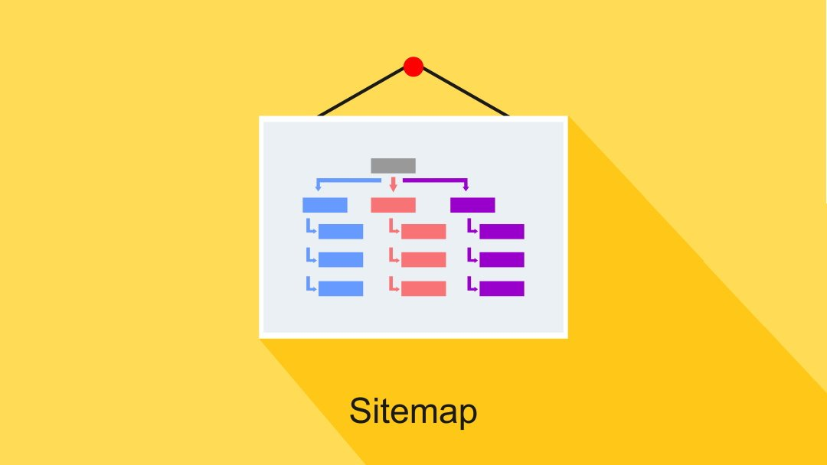

sitemap is a structured list of pages that you want to crawl and index your website to search engine bots. It is way to report to google pages we might not otherwise find on your site. Sitemaps guides bots, that visit the site such as Googlebot , to better index the website. The extension of the sitemap file is XML. The effect of it is excellent at the indexing speed of search engines

sitemaps divide into many kinds:

* Visual
* Video
* Google news
* Mobile
* Product sitemaps 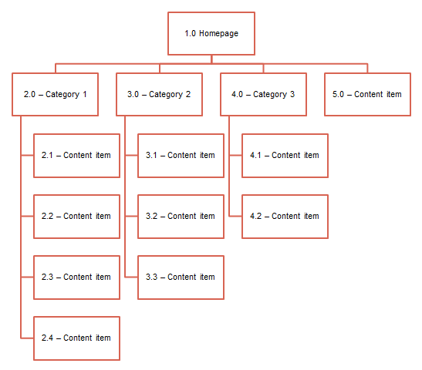
* Language page and so on.

Sitemaps are useful in several ways:

* They show how the navigation should be structured
* They help identify where content will sit and what needs to be produced
* They help show the relationship between different pages
* They provide a structure upon which to begin estimates for development
* They are the first tangible deliverable showing what you will be creating

The sitemap you ultimately create needs to have a few key attributes:

* A homepage/home screen item at the top
* A reference number for each item in the sitemap (This helps when creating wireframes or functional specifications)
* A label for each item in the site map

**Different types of sitemaps**

There are two types of sitemaps

* XML sitemap(for crawler)
* HTML sitemap(for user)

XML SITEMAP

* A xml sitemap is a file that lists a websites important pages , making sure google can find and crawl them all. It is also help search engine understand your website structure.
* You want google to crawl very essential page of your website . but sometimes , page end up without any internal links pointing to them making them hard to find . a sitemaps can help speed up content discovery

**HTML SITEMAP**

* A HTML sitemap enables lost human users to find a page on your site that they are looking for,

Example :- webpage footer page

* It is basically for the user to navigate the page.

